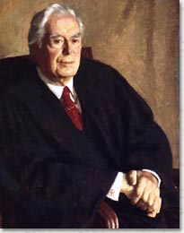
Warren Earl Burger
Born: September 17, 1907, St. Paul, MN
Died: June 25, 1995, Washington, D.C.
Fifteenth Chief Justice of the Supreme Court
(1969-1986)
Warren Earl Burger grew up on the outskirts of St. Paul in a working-class family. His father was a cargo inspector for the railroads and a traveling salesman. He received his law degree in 1931 and joined a local law firm, specializing in corporate and real estate work, where he continued for the next 22 years. In 1953 President Eisenhower appointed him Assistant Attorney General for the Civil Division of the Justice Department. When Richard Nixon ran for president in 1968, he promised to put the Supreme Court back on a conservative path, and after winning the election, Nixon appointed Burger to chief justice. Burger had a very strong ethical record, and Nixon hoped he would provide the strong leadership needed to control the Court's expansion of civil rights and civil liberties. Burger was in charge of the Court for 17 years, but he was not able to strongly influence its judicial philosophy.
Often appearing “closed off” and even unfriendly in the press, Burger was generally respected by those close to him, and he tried to steer the Court toward moderate decisions at a time of shifting national values and cultural revolutions. Perhaps the Court’s biggest decision occurred in 1974 when they ruled that the Constitution protected a woman's right to privacy and control over her own body, thus striking down outright abortion bans. This was called Roe v. Wade. Burger and the other eight justices reached controversial rulings on affirmative action as well (Regents of the University of California v. Bakke, 1978) where it was ruled that “affirmative action”, or the establishment of admissions quotas for minority students into colleges and universities was concurrent with previous legislation. Affirmative action would exist “…only for the purpose of improving the learning environment through diversity in accordance with the university's constitutionally protected First Amendment right to Academic Freedom. Burger retired from the Court in 1986.

#1

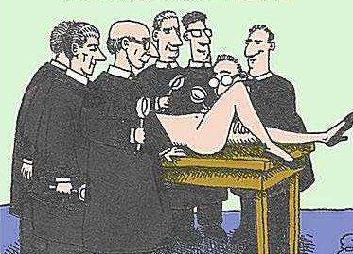

A political cartoon satirizing (making fun of) 1974’s Roe v. Wade. Too invasive?

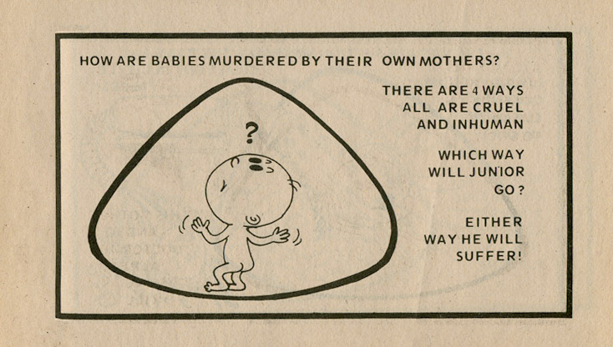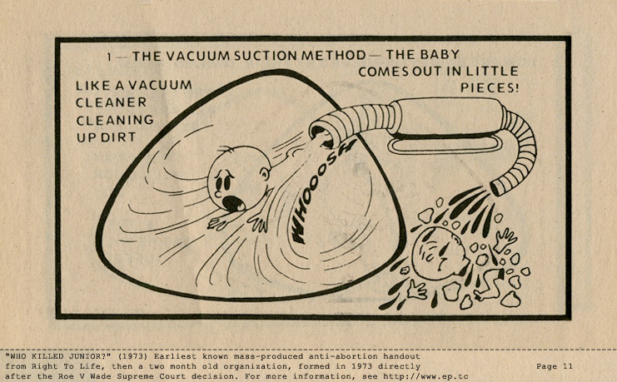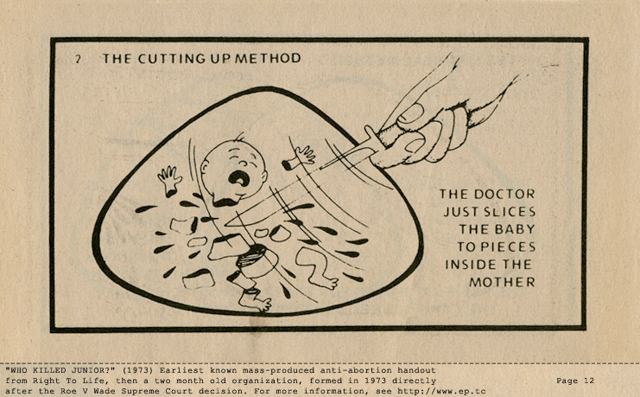
#2
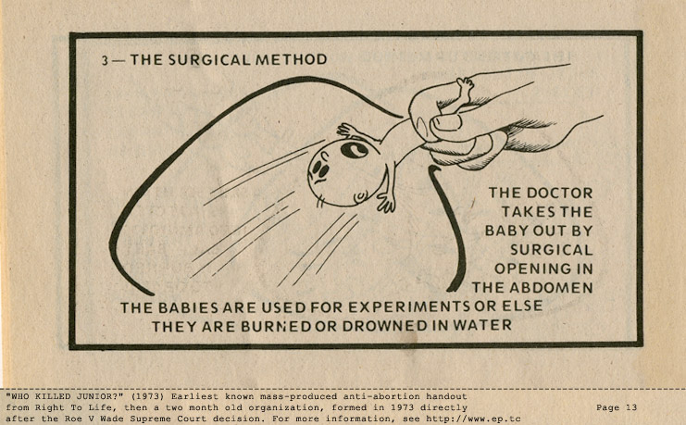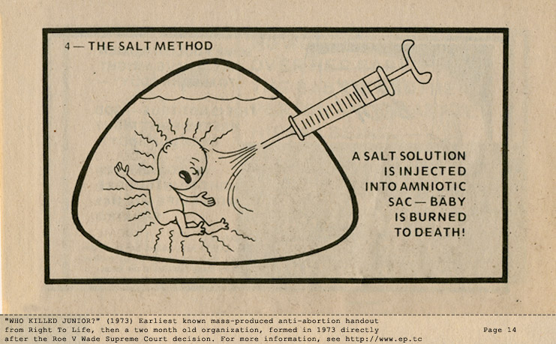
There were many attempts to persuade people that abortion was a disgusting and horrific action. Nonetheless, in 1974, Roe v. Wade gives the woman a right to choose

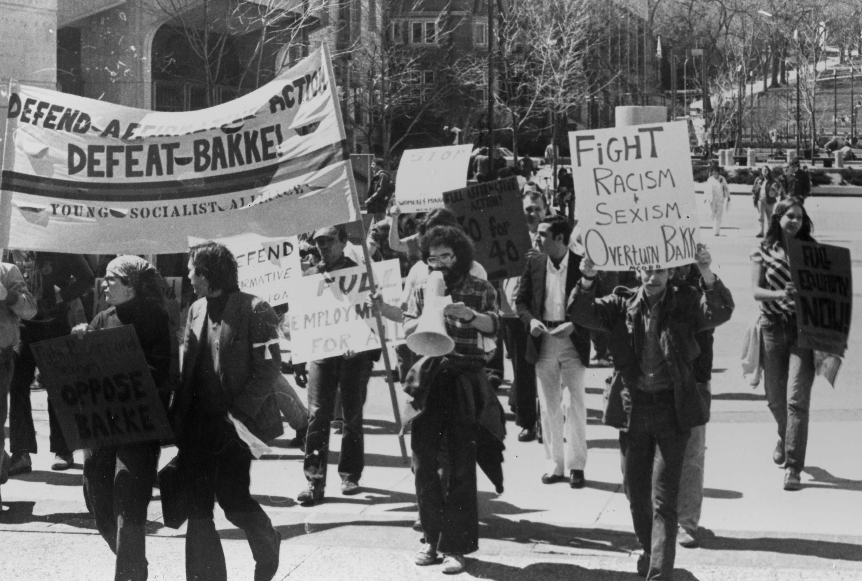

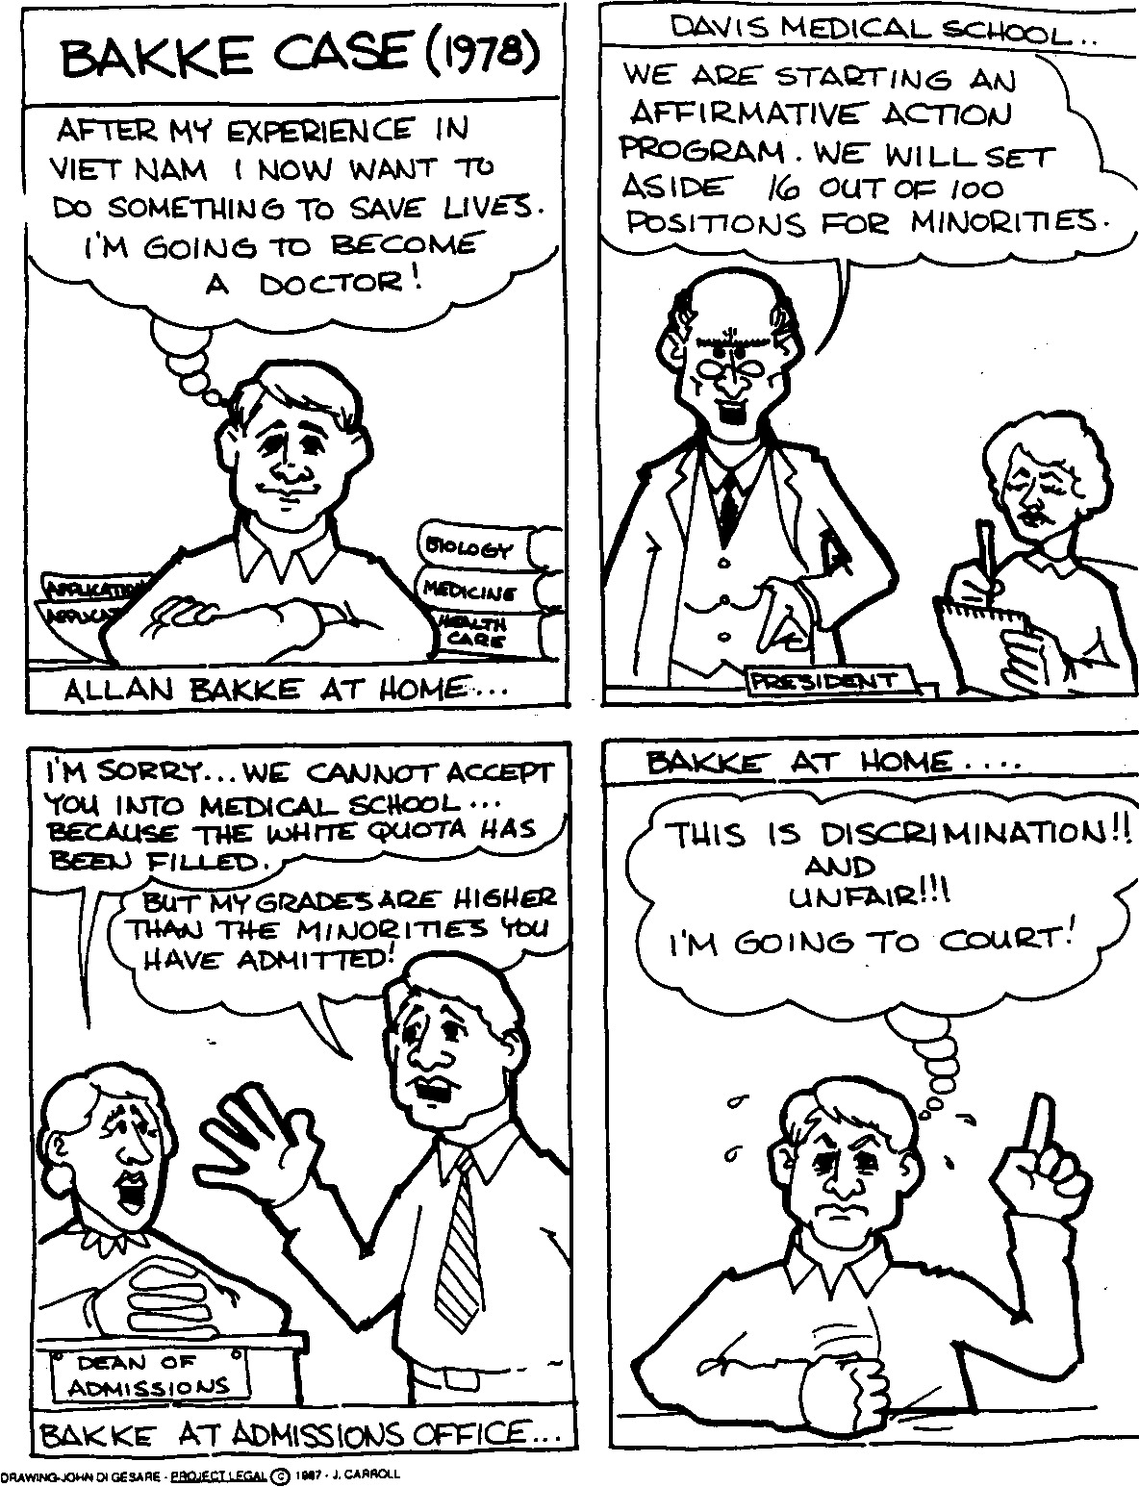
#3
Allan Bakke was upset that he was denied entry into college because he was White, and the school needed to admit minorities. He took the case to the Supreme Court.

#4

Many people spoke AGAINST Bakke, believing that minorities DO, in fact, need affirmative action to level the playing field of getting into college.

