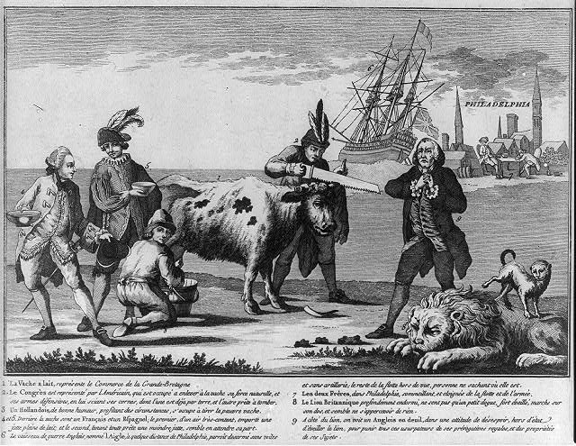
Spain
The Dutch
France
United States
England
American “bitch” (dog)
1
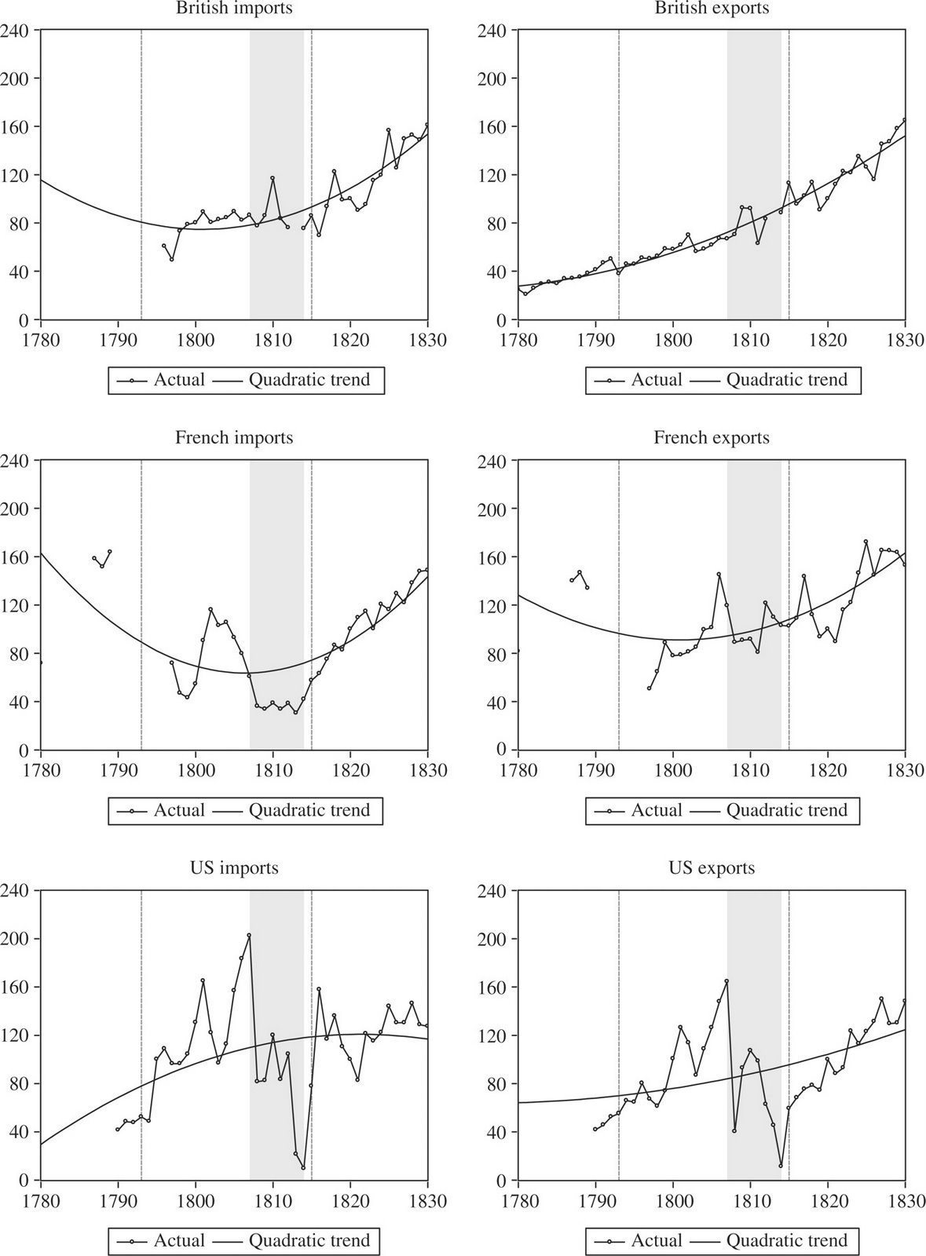
2
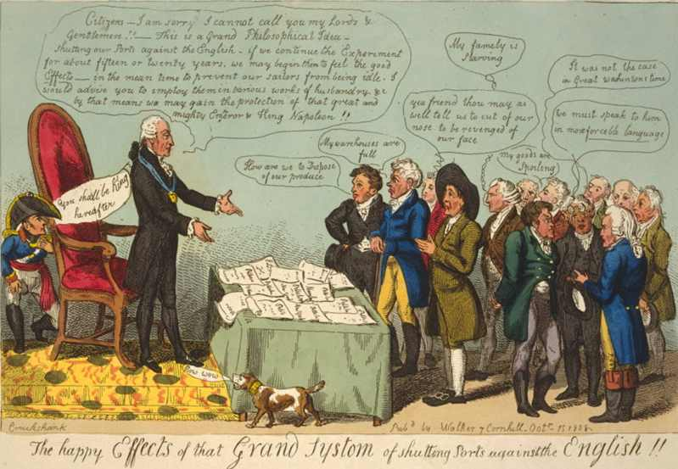
Citizens, I am sorry! I cannot call you my Lords and Gentlemen!! This is a Grand Philosophical Idea – shutting our Ports against the English. If we can continue the Experiment for about fifteen or twenty years, we may begin then to feel the good Effects. In the meantime, to prevent our sailors from being idle, I would advise you to employ them in various works of industry. And by that means, we may gain the protection of that great and mighty Emperor and King Napoleon!
How are we to export our produce?
My warehouses are full!
My family is starving!
It was not the case in Great Washington’s time!
My goods are spoiling!
3
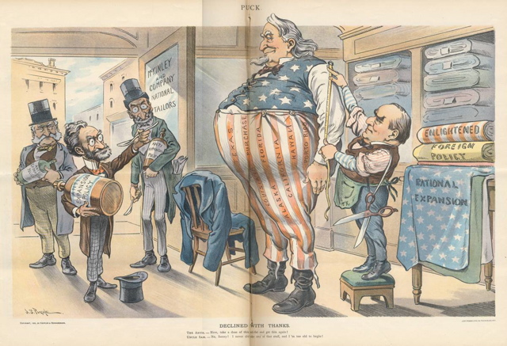
4

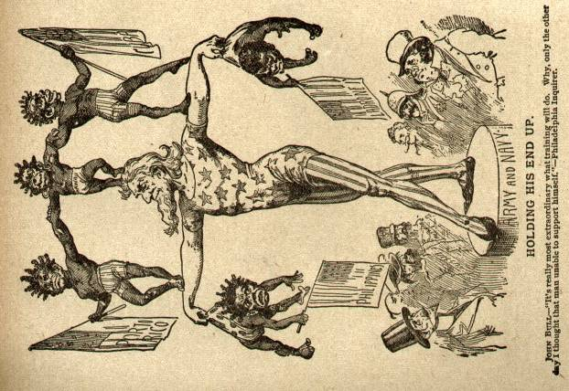
5

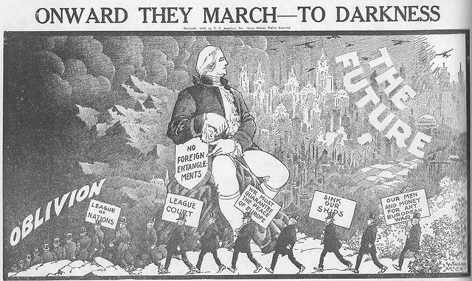
6

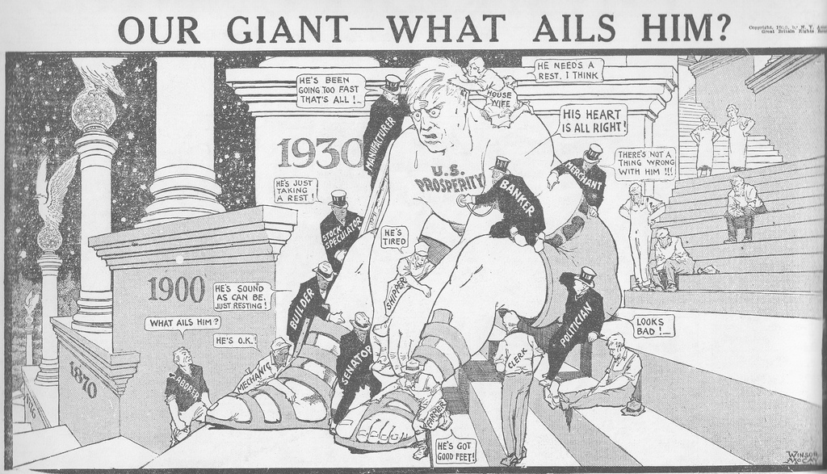
7

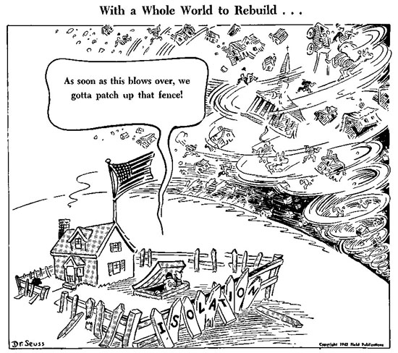
8
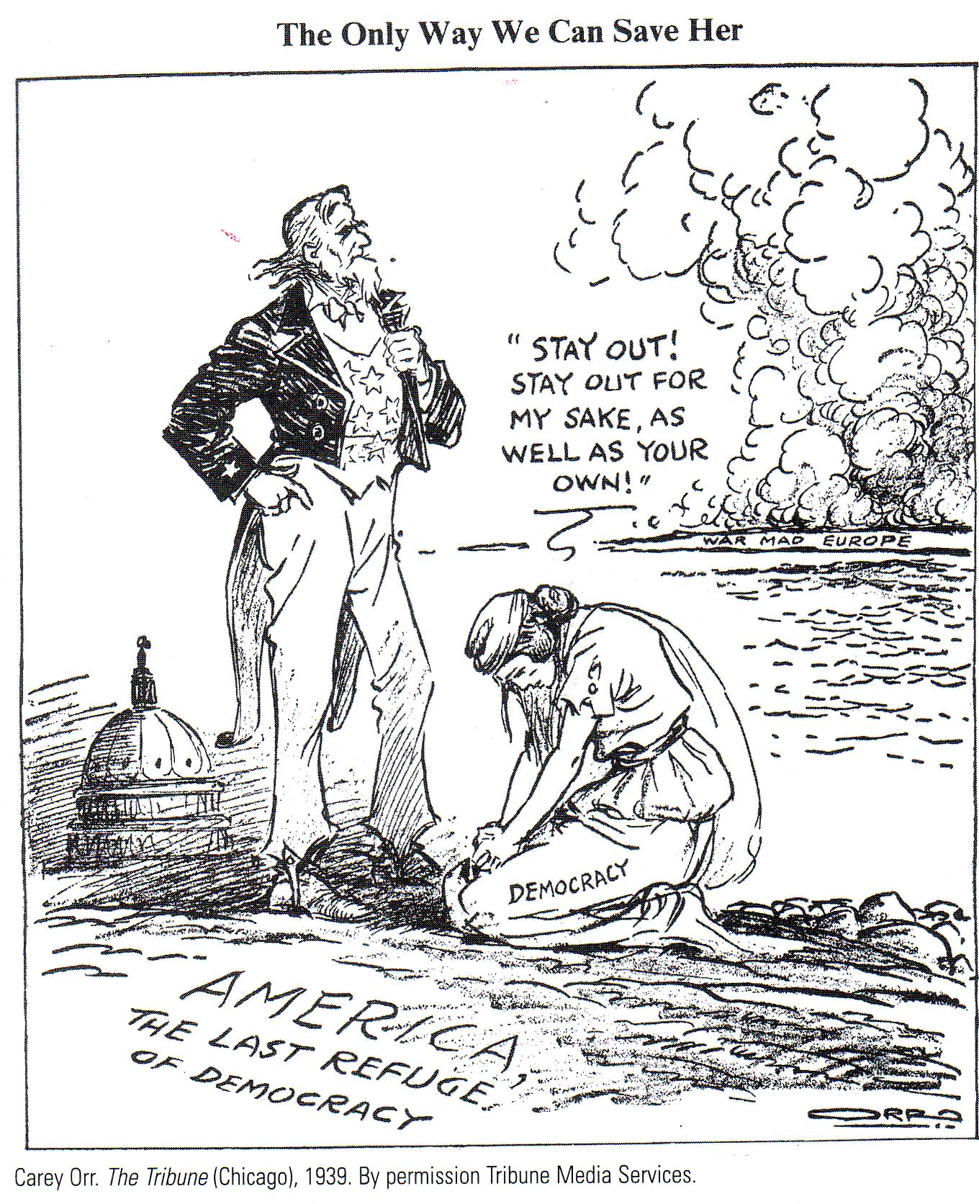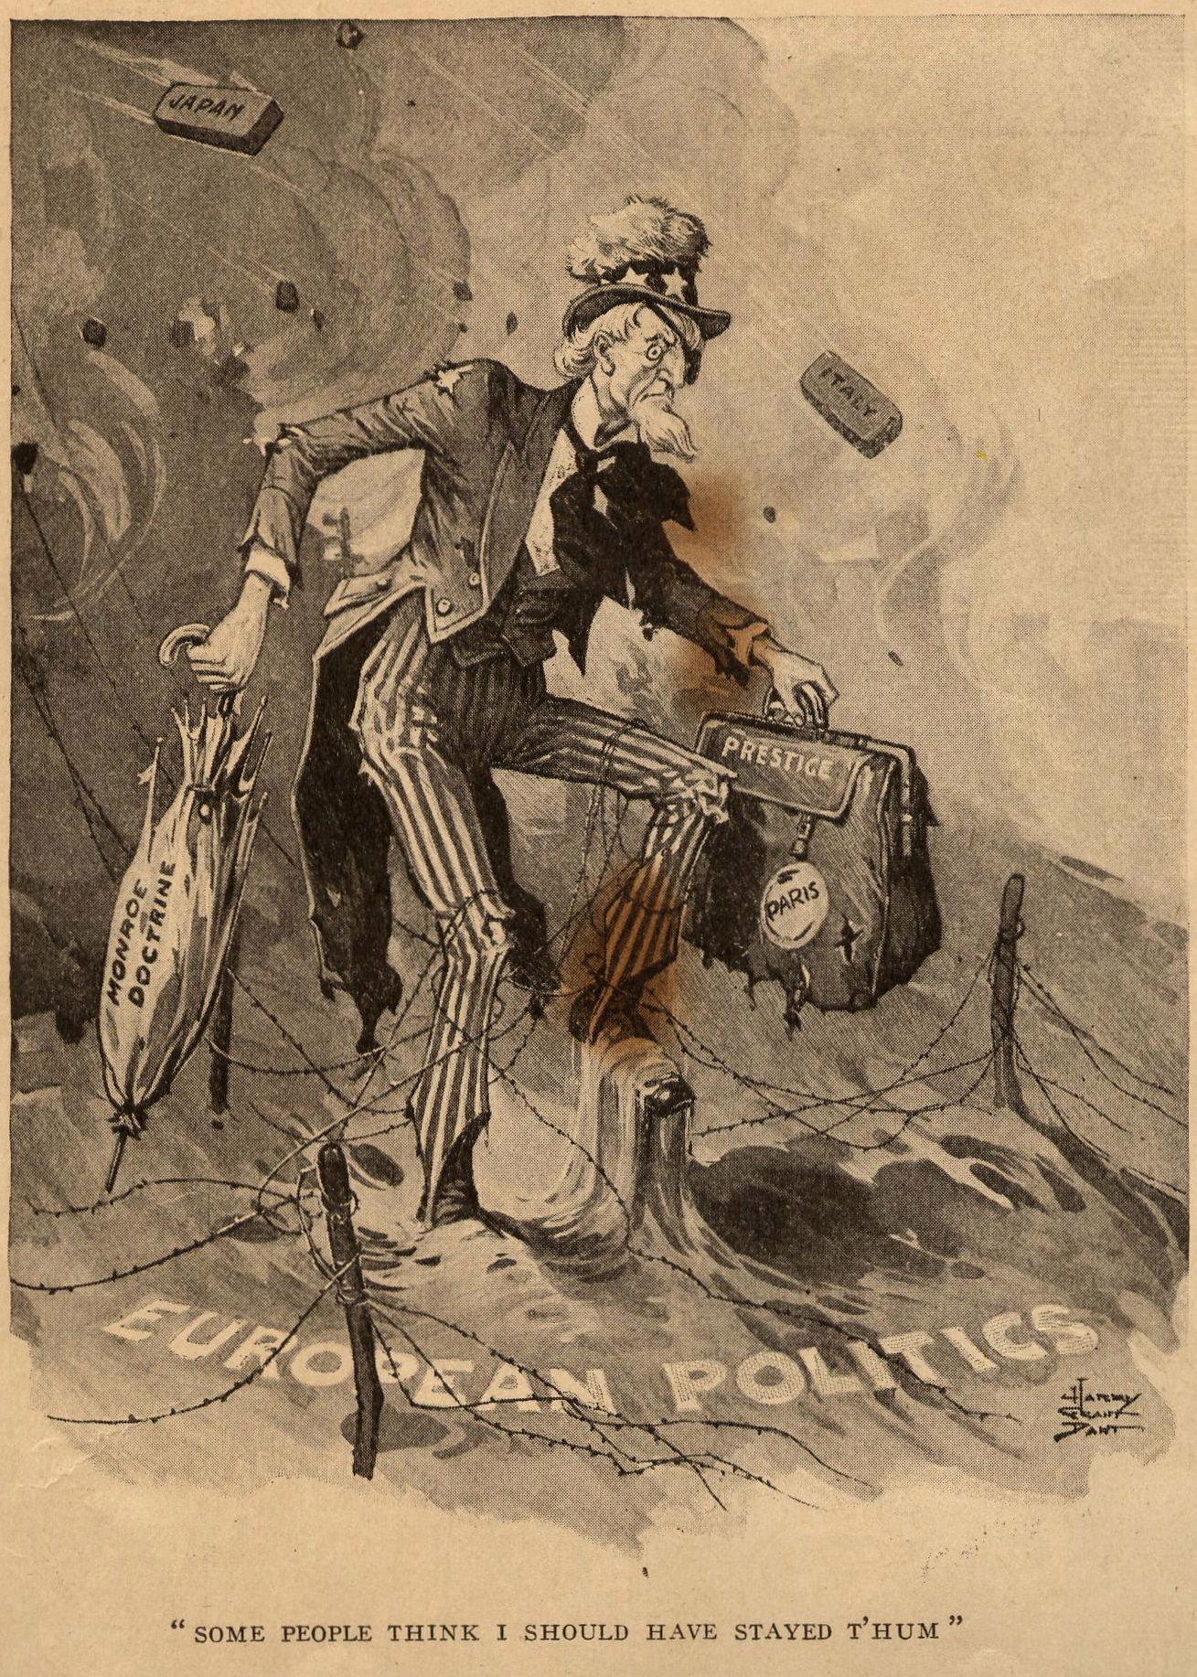
9
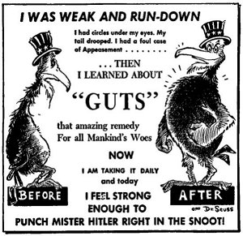
10
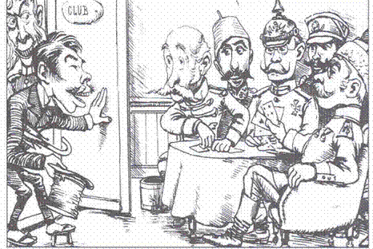
Japan
U.S.
Belgium
England
Italy
France
11
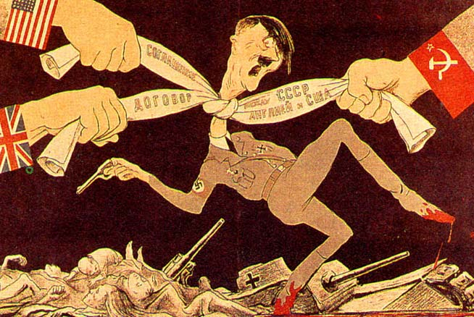
12
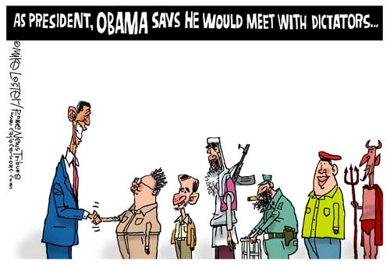
North Korea
Iran
Taliban
Cuba
Venezuela
Hell?
13
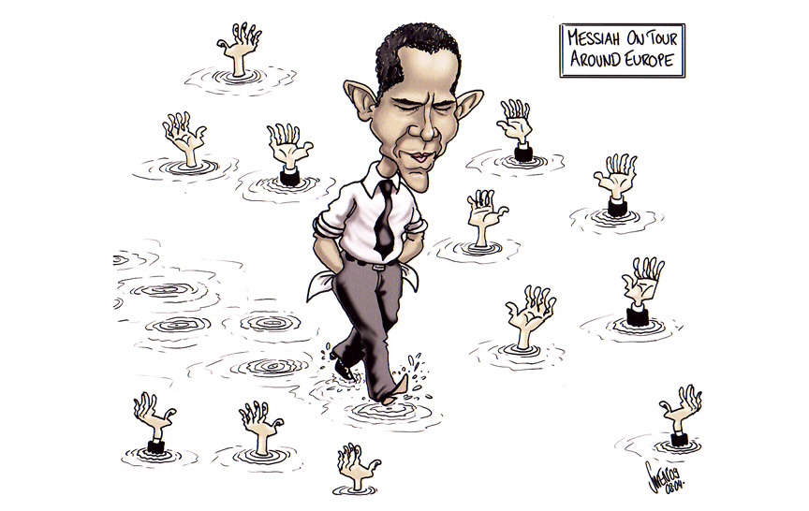
14

