In Praise of Oligarchy
JEFFREY A. WINTERS, The American Interest and HYWEL WILLIAMS, The Guardian, U.K.
November / December 2011; September 2002

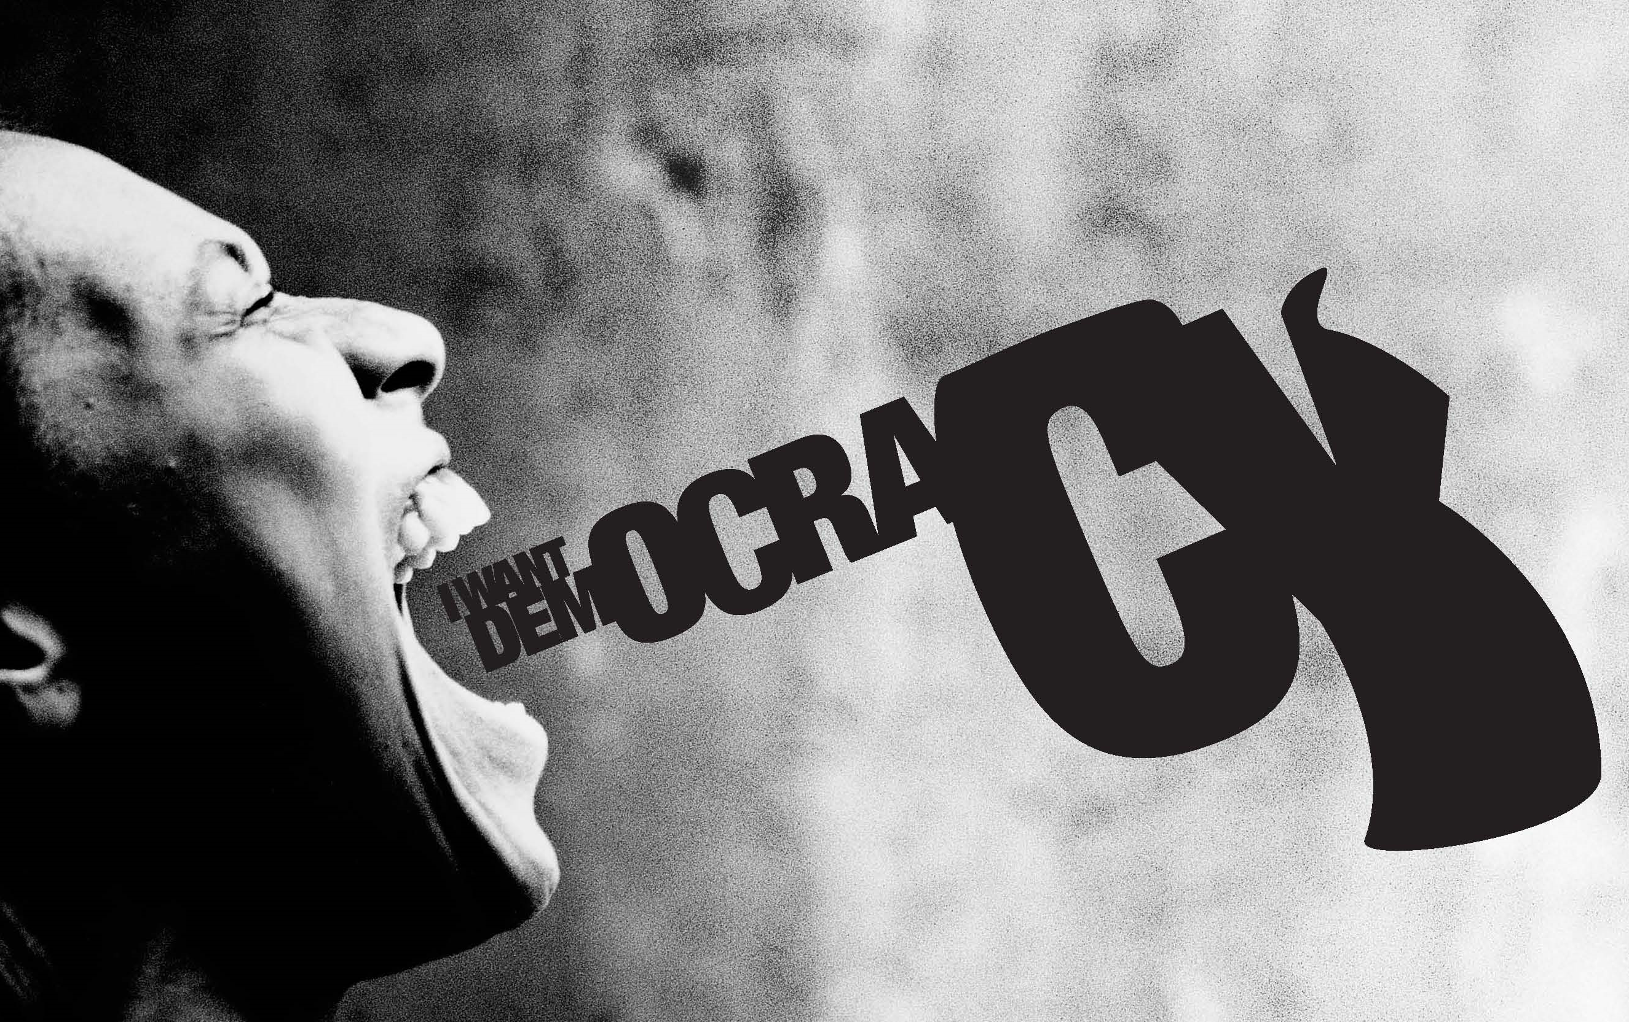
It is a confounding moment in American political history. On the one hand, evidence of democratic possibilities is undeniable. In 2008, millions of Americans helped catapult a man of half-African descent into the White House long before observers thought the nation was “ready.” On the other hand, democracy appears chronically dysfunctional when it comes to policies that affect the rich. Despite polls consistently showing that large majorities favor increasing taxes on the wealthiest Americans, policy has been moving for decades in the opposite direction. Reduced taxes on the ultra-rich have strained the government’s capacity to maintain infrastructure, provide relief to children and the poor, and assist the elderly.

But, America’s ultra-rich all together could barely fill a large sports stadium. They never assemble for rallies or marches, sign petitions, or mount Facebook or Twitter campaigns. So how do they so consistently get their way?

One increasingly popular answer is that America is an oligarchy rather than a democracy. The complex truth, however, is that the American political economy is both an oligarchy and a democracy; oligarchy rests on the concentration of material power, democracy on the dispersion of non-material power. The American system, like many others, pits a few with money power against the many with participation power.

Oligarchy within Democracy
When democracy combines with oligarchy, the result is a distinctive fusion of equality and inequality. In the 1950s, the claim was that the United States was dominated by a tiny segment of the population that commanded major institutions across society and shared privileges of status, education, access and comfortable living standards.

The current focus on oligarchs is different. Unlike elites, who are empowered in diverse ways and are oriented toward diverse ends, oligarchs are defined more uniformly by the power of money. Concentrated wealth serves as both the source of oligarchic power and the motivation to exercise it. Unlike any other power resource, wealth unites oligarchs politically around a core set of shared interests because, throughout human civilization, great riches have always attracted threats. Whatever their political disagreements, oligarchs in America, as elsewhere, are motivated and connected by the desire to deflect threats to their fortunes. Being networked certainly augments the influence of oligarchs, but coordination is not the primary source of their political power.

Oligarchy should be understood as the politics of wealth defense, which has evolved in important ways throughout human civilization. For most of history, this has meant oligarchs were focused on defending their claims to property. They did so by arming themselves or by ruling directly and jointly over armed forces they assembled and funded. Every great increase in wealth required oligarchs to spend additional resources on armaments, castles, militias and other means of defense.

Democracy, on the other hand, is a preachy kind of governmental business. High claims of virtue are part of the common currency in this lingua franca because of the democrats' faith that theirs is not a creed just for the here and now. Oligarchic societies understand that government is first and foremost about security - a value and an achievement that democratic universalism often takes for granted. But the fragility of existence is soon lost sight of when democrats are in the saddle - exercising their right to intervene and improve and legislate in the name of their particular version of progress. All the talk of human happiness and rights has resulted in so many varieties of managerial modernity. Direct democracy having never been attempted systematically, we suffer the consequences of the representative kind.
The essence of oligarchy within democracy rests on the near-veto power oligarchs retain on threats to concentrated wealth. On all other issues, oligarchs’ views and positions are as disunited and democratically contested as those held by everyone else across the society. Thus, there is no oligarchic stance on abortion, immigration or the rights of women.

“America does not have oligarchs, it has rich people”, declared one of my seminar students at Northwestern University. This could only be true if wealth were somehow stripped of its inherent political potency. Whatever else American democracy has achieved, it has not managed this. Rather, oligarchy and democracy operate within a single system, and American politics is a daily display of their interplay. Indeed, it is a misreading of oligarchic theory dating back to Aristotle to view oligarchy and democracy as mutually exclusive, or to suggest that democracy is a sham if oligarchs exist and exercise their power routinely and effectively. Aristotle called for an ideal political system, the polity, that combines oligarchy and democracy so deftly that “there should appear to be both elements and yet neither.”

Universal suffrage and liberal freedoms empower all citizens in a radically equal manner. But the one-person/one-vote principle does little to prevent oligarchs from exercising the power of money in a manner that is profoundly unequal. Formal juridical equality is essential to human freedom. But full political equality, even in the most liberal democracy, is impossible as long as concentrated wealth places grossly unequal political influence in the hands of a few citizens. Democracy fused with oligarchy is certainly better than no democracy at all. But there should be no illusions that it is anything other than a partial step toward full political equality and representation.

