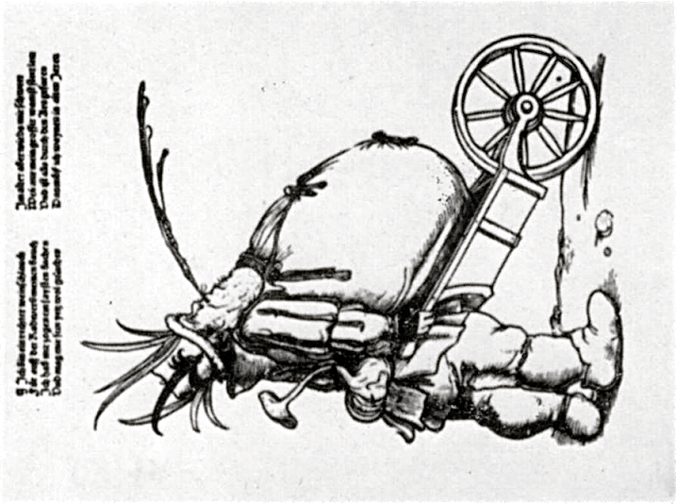

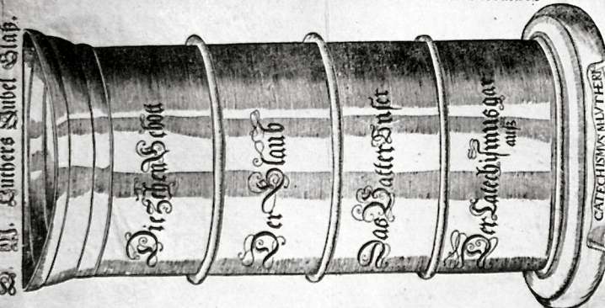

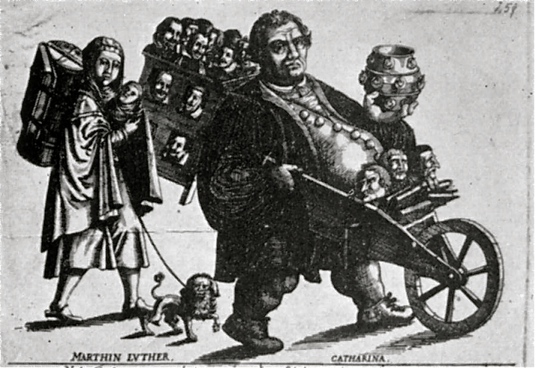

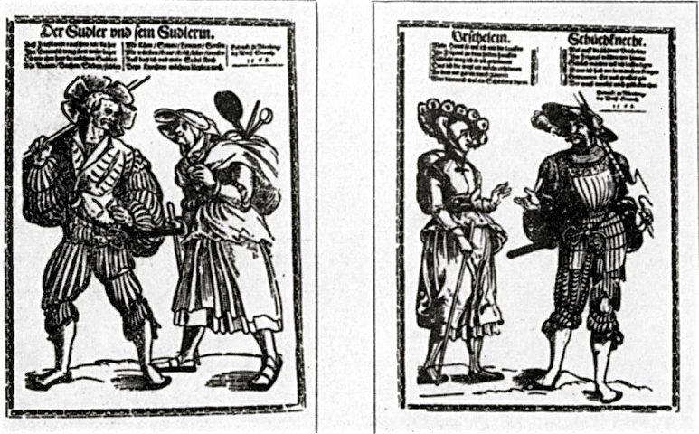
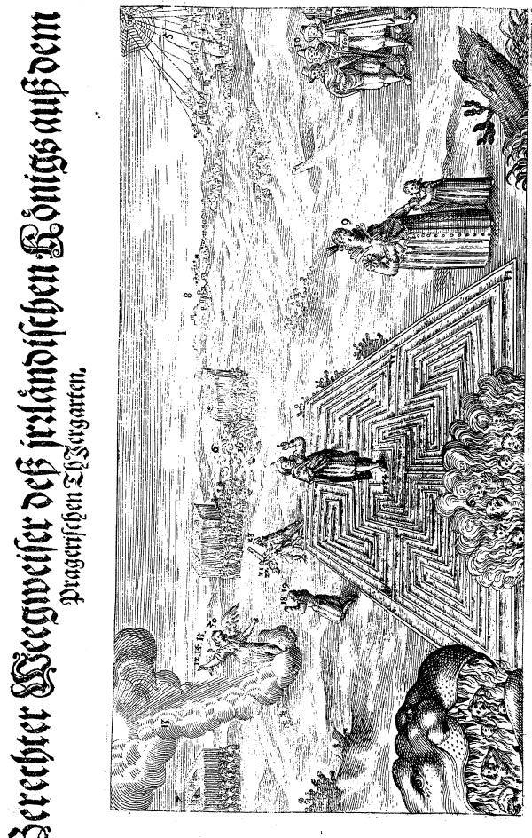
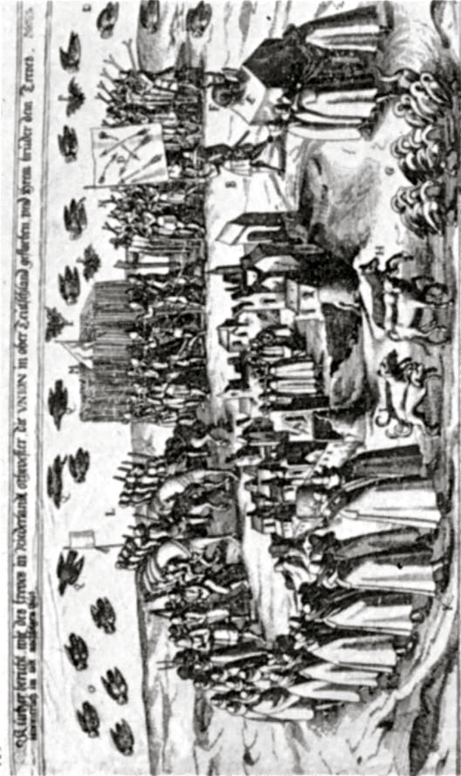

Cartoon 1
(Two images on One Page)

The image on the left from the year 1620 satirizes Luther through the illustration of his large drinking glass, justifying the Catholic view of Luther as a monster of gluttony and sexual immorality by detailed reference to the Reformer's written work and the table talk. In life, Luther took pride in being “peasant-like”, able to each and drink with the commoners. But in this cartoon, his somewhat robust attitude to relations between the sexes is now made to bear witness against him.

The image on the right, called Der Weinschlauch (“The Wine Skin”), shows Martin Luther as an enormously fat man who spews wine and rests his bloated belly on a barrow. It’s created to show Luther as a monster of gluttony, whose evangelizing in Bohemia (Central Europe) has made him so “fat with pleasure” than he cannot support his own weight, literally and metaphorically…

Cartoon 2

This image shows the expulsion of Lutheran preachers from Bohemia by the victorious Catholics, 1620. On Luther’s back are numerous Lutheran preachers. In his left hand is the cup of his “abominations”, drawing comparison between him and the “Whore of Babylon”, a seven-headed, and ten-horned partner of the Anti-Christ whose presence is revealed in the Book of Revelations in the Bible. Her more appropriate title is "Babylon the Great, the Mother of Prostitutes and Abominations of the Earth", so it’s quite clear how the Catholics thought of Luther! Luther’s wife, Catharina von Bora, has a child in her arms and leads a “dog of envy and discontent” with her.

Cartoon 3

This image shows the “Wanderers” leaving King Fredrick V’s Palatine region of Western Germany. King Frederick, one of the heads of the Protestant League, was hated by Catholics, and this cartoon serves to suggest that the king has lost the power of his people. The people wander, as they are victim to a “king without a kingdom”

Cartoon 4

When Pope Paul V heard that Frederick had accepted the crown of Bohemia, he exclaimed that Frederick had "entered a filthy labyrinth in which he would irretrievably be lost". And according to the cartoonist, this appears to be true. King Frederick V, of the Palatine Region of Germany, and one of the heads of the Protestant League, stands in the midst of the labyrinth; on the right his creditors and his wife - by her vain ambition one of the chief causes of Frederick's downfall - are to be seen, while armies fight in the background and a spider - a graphic pun on the name of the Spanish Imperialist General Spinola - casts its web over the conquered Palatinate. On the left stands an angel above the jaws of Hell who appeals to Frederick to renounce the Calvinism which is responsible for his crime and present punishment.

Cartoon 5

This image, although the quality is not great, shows a great deal of horrific and symbolic detail. Called “Begräbnis der Union” (“The Burial of the Union”), a series of cartoons were created to show the “abortive attempts” of the Protestant Union to seize political power in terms of the miscarriage of a female figure. The horse-cure to which she is subjected by her Spanish doctor, Spinola, is so drastic that she dies as a result of it, having first made an ironical will.

Once she is dead, as you see in this picture, she is treated to the elaborate mock funeral which is described in detail. At the center of the engraving a coffin is being lowered into a grave in a nameless city.

Around the city winds the funeral procession, led by a standard-bearer who carries a flag on which appear several broken arrows, to signify the broken state of the Union.

On the coffin itself sits a hare eating a piece of meat as an allegory on the cowardly nature of the Union and its attempts to appear as a fierce carnivore.

Behind the coffin walk thirteen geese, three calves and three dogs who symbolize the thirteen years, three months and three days of the Union's lifespan.

The rest of the procession is made up of mourners and a military escort, the latter bearing inverted pikes and muskets by way of mourning and as a commentary on the failure of the military ambitions of the Union.

The number symbolism is repeated in the thirteen owls, three bats and three ravens - all birds of ill omen - which fly overhead.

